**Day 8 Assignment OOPs**

1. Write a “person” class to hold all the details.

class Person{

constructor(name,job,phone,city){

    this.name=name;

    this.job=job;

    this.phone=phone;

    this.city=city;

}

getPersondetails(){

    console.log(`The details of ${this.name} are as follows

    Name : ${this.name}

    Job : ${this.job}

    Phone-no : ${this.phone}

    City : ${this.city}

    `)

}

}

let person1 = new Person("Kaushik","student",9111086733,"Bangalore");

person1.getPersondetails();

let person2 = new Person("vivek","software Engineer",9111765733,"Chennai");

person2.getPersondetails();

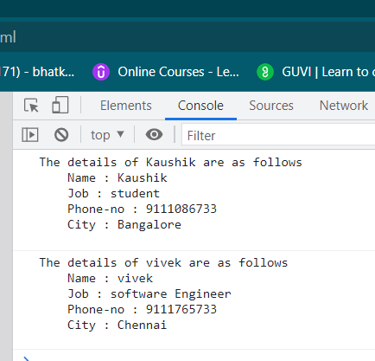output

2. write a class to calculate uber price.

class Uber{

constructor(distance,type_of_vehicle){

    this.distance=distance;

    this.type_of_vehicle=type_of_vehicle;

}

displayPrice(){

    let pricefordistance=0;

   if(this.type_of_vehicle=="auto"){

     pricefordistance=this.distance*9;

     console.log(`the price is ${pricefordistance} Rupees`);

   }

   else if(this.type_of_vehicle=="uber-go"){

    pricefordistance=this.distance*14;

    console.log(`the price is ${pricefordistance} Rupees`);

  }

  else if(this.type_of_vehicle=="uber-prime"){

    pricefordistance=this.distance*16;

    console.log(`the price is ${pricefordistance} Rupees`);

  }

}

}

let customer1 = new Uber(10,"auto");

customer1.displayPrice();

let customer2 = new Uber(10,"uber-go");

customer2.displayPrice();

let customer3 = new Uber(10,"uber-prime");

customer3.displayPrice();

output

